

**“ELECTRIC WATER LEVEL CONTROL SYSTEM”**

**A MINI PROJECT**

**REPORT**

*Submitted by*

**K.CHANDRIKA (1NH18EC048)**

***In partial fulfillment for the award of the degree of***

**BACHELOR OF ENGINEERING**

IN

**ELECTRONICS AND COMMUNICATION**

**ENGINERRING**

**NEW iiHORIZON iiCOLLEGE iiOF iiENGINEERING**

**DEPARTMENT iiOF iiELECTRONICS iiAND iiCOMMUNICATION iiENGINEERING**



**CERTIFICATE**

Certified iithat iithe iimini iiproject iiwork iientitled ii“**ELECTRIC WATER LEVEL CONTROL SYSTEM**” iicarried I iout **IK.CHANDRIKA(1NH18EC048) ii**bonafide iistudents iiof iiElectronics iiand iiCommunication iiDepartment ii, iiNew iiHorizon iiCollege iiof iiEngineering, iiBangalore. ii

The iimini iiproject iireport iihas iibeen iiapproved iias iiit iisatisfies iithe iiacademic iirequirements iiin iirespect iiof iimini iiproject iiwork iiprescribed iifor iithe iisaid iidegree.

Project iiGuide ii ii iiHOD iiECE

DR. Sanjeev Sharma ii ii ii iDR.Sanjeev Sharma

HOD, dept of ECE, HOD, dept of ECE,

NHCE, Bengaluru. NHCE, Bengaluru.

**External iiViva**

Name iiof iiExaminer Signature iiwith iiDate

1.

2.

**ACKNOWLEDGEMENT**

The iisatisfaction iithat iiaccompany iithe iisuccessful iicompletion iiof iiany iitask iiwould iibe, iibut iiimpossible iiwithout iithe iimention iiof iithe iipeople iiwho iimade iiit iipossible, iiwhose iiconstant iiguidance iiand iiencouragement iihelped iius iisucceed.

We iithank ii**Dr. iiMohan iiManghnani**, iiChairman iiof ii**New iiHorizon iiEducational iiInstitution**, iifor iiproviding iinecessary iiinfrastructure iiand iicreating iigood iienvironment.

We iialso iirecord iihere iithe iiconstant iiencouragement iiand iifacilities iiextended iito iius iiby ii**Dr.Manjunatha**, iiPrincipal, iiNHCE iiand ii**Dr. iiSanjeev iiSharma**, iihead iiof iithe iidepartment iiof iiElectronics iiand iiCommunication iiEngineering. iiWe iiextend iisincere iigratitude iito iithem.

We iisincerely iiacknowledge iithe iiencouragement, iitimely iihelp iiand iiguidance iito iius iiby iiour iibeloved iiguide ii**DR. Sanjeev Sharma** iito iicomplete iithe iiproject iiwithin iistipulated iitime iisuccessfully.

Finally, iia iinote iiof iithanks iito iithe iiteaching iiand iinon-teaching iistaff iiof iielectronics iiand iicommunication iidepartment iifor iitheir iico-operation iiextended iito iius, iiwho iihelped iius iidirectly iior iiindirectly iiin iithis iisuccessful iicompletion iiof iimini iiproject.

**K.CHANDRIKA(1NH18EC048)**

**ABSTRACT**

The iidrinking iiwater iicrisis iiin iiAsia iiis iireaching iialarming iiproportions. iiIt iimight iivery iisoon iiattain iithe iinature iiof iiglobal iicrisis. iiHence, iiit iiis iiof iiutmost iiimportance iito iipreserve iiwater iifor iihuman iibeings. iiIn iimany iihouses iithere iiis iiunnecessary iiwastage iiof iiwater iidue iito iioverflow iiin iioverhead iitanks. iiAutomatic iiWater iiLevel iiIndicator iiand iiController iican iiprovide iia iisolution iito iithis iiproblem. iiThe iioperation iiof iiwater iilevel iicontroller iiworks iiupon iithe iifact iithat iiwater iiconducts iielectricity iidue iito iithe iipresence iiof iiminerals iiwithin iiit. iiSo iiwater iican iibe iiused iito iiopen iior iiclose iia iicircuit. iiAs iithe iiwater iilevel iirises iior iifalls, iidifferent iicircuits iiin iithe iicontroller iisend iidifferent iisignals. iiThese iisignals iiare iiused iito iiswitch iiON iior iiswitch iiOFF iithe iimotor iipump iias iiper iiour iirequirements. iiThe iitotal iiamount iiof iiwater iiavailable iion iiEarth iihas iibeen iiestimated iiat ii1.4 iibillion iicubic iikilometers, iienough iito iicover iithe iiplanet iiwith iia iilayer iiof iiabout ii3 iikm. iiAbout ii95% iiof iithe iiEarth's iiwater iiis iiin iithe iioceans, iiwhich iiis iiunfit iifor iihuman iiconsumption. iiAbout ii4% iiis iilocked iiin iithe iipolar iiice iicaps, iiand iithe iirest ii1% iiconstitutes iiall iifresh iiwater iifound iiin iirivers, iistreams iiand iilakes iiwhich iiis iisuitable iifor iiour iiconsumption. iiA iistudy iiestimated iithat iia iiperson iiin iiIndia iiconsumes iion iian iiaverage iiof ii140 iilitres iiper iiday. iiThis iiconsumption iiwould iirise iiby ii40% iiby iithe iiyear ii2025. iiThis iisignifies iithe iineed iito iipreserve iiour iifresh iiwater iiresources.

A iiwater iilevel iiindicator iimay iibe iidefined iias iia iisystem iiby iiwhich iiwe iican iiget iithe iiinformation iiof iiwater iiwithin iithe iireservoir. iiWater iilevel iiindicator iisystems iiare iiquite iiuseful iito iireduce iithe iiwastage iiof iiwater iifrom iiany iireservoir, iiwhile iifilling iisuch iireservoir. iiThe iiwires iiwith iicolors iiBlue, iiRed, iiGreen ii& iiYellow iiare iiadjusted iito iicheck iiLevel ii1, iiLevel ii2, iiLevel ii3 iiand iiLevel ii4 iirespectively. iiEach iiof iithese iifour iiwires iiare iiconnected iito iithe iiamplifier. iiIn iithis iiproject iiwe iihave iidesigned iithe iisensor iito iimeasure iiwater iiup iito iifour iilevels. iiFour iisegments iiof iiinsulated iiconducting iiwires iiare iiused iiand iithe iinaked iiends iiwithin iiwater iiare iiconnected iiwith iicarbon iirods. iiThe iilength iiof iithe iiwire iisegments iiare iiadjusted iiaccording iito iithe iiwater iilevels iiwithin iithe iireservoir.

**Keywords**: iiWater iiLevel iiIndicator, iiController, iiconducting iiwires.

ii

**Chapter-I**

**Introduction**

**A ii**Water iiLevel iiIndicator iimay iibe iidefined iias iia iisystem iiby iiwhich iiwe iican iiget iithe iiinformation iiof iiany iiwater iireservoir. iiWater iilevel iiindicator iisystem iiis iiquite iiuseful iito iireduce iithe iiwastage iiof iiwater iifrom iiany iireservoir, iiwhile iifilling iisuch iireservoir. ii

Water iiis iimost iiessential iithing iion iiearth ii.Safe iidrinking iiwater iiis iiessential iito iihuman iiand iiother iilife iiforms iieven iithough iiit iiprovides iino iicalories iior iiorganic iinutrients.

The iiproject iiwe iihave iidone iiis iiwater iilevel iiindicator iiwith iialarm. iiThis iiis iian iiindustrial iidefined iiproject iii.e. iiIDP. iiAnd iithe iititle iiis iiso iigiven iifrom iithe iiproblem iidefine ii“Level iiof iithe iiwater iiin iithe iitank”. iiwe iigot iithe iiabove iimentioned iiproblem iidefinition iifrom iiour iiresearch iiand iiunderstanding.

The iiBasic iicomponents iiinvolved iiin iithe iidesign iiof iilevel iiindicator iiare iifollowing:

* Transistor(BC547)
* Resistor(220 iohm)
* LED
* Buzzer
* Connecting iWires
* Breadboard

Scope:

ii ii ii ii ii ii ii ii ii ii ii ii ii iiThis iicircuit iinot iionly iiindicates iithe iiamount iiof iiwater iipresent iiin iithe iioverhead iitank iibut iialso iigives iian iialarm iiwhen iithe iitank iiis iifull. iiThis iiworthy iidevice iistarts iiringing iias iisoon iias iithe iiwater iitank iibecomes iifull. iiIt iihelps iito iicheck iioverflow iiand iiwastage iiof iiwater iiby iiwarning iithe iicustomer iiwhen iithe iitank iiis iiabout iito iibrim. iiThe iisystem iiprovides iivisual iiwater iilevel iiindication iiwith iiaudio iialarms iiat iidesired iilevels. iiIt iialso iiprovides iiautomatic iicontrol iiof iipumps iiat iia iiremote iilocation.

Now iino iineed iito iigo iion iithe iiroom iito iilook iithe iiwater iilevel.

* It iishows iithe iiwater iilevel iiin iiyour iiroom iilike ii iilevel i1 i,level i2 iand i ilevel i3
* Alarm iistarts iiringing iias iisoon iias iitank iibecomes iifull.
* Suitable iifor iievery iitank

**Chapter-II**

**Literature iisurvey**

[1] S. M. Khaled Reza, Shah Ahsanuzzaman Md. Tariq, S.M. Mohsin Reza ,“Microcontroller Based Automated Water Level Sensing and Controlling: Design and Implementation Issue”, 0, San Francisco, USA

[2] Ria Sood, Manjit Kaur, Hemant Lenka , “ DESIGN AND DEVELOPMENT OF AUTOMATIC WATER FLOWMETER”, Mohali, India

[3] Sanam Pudasaini, Anuj Pathak, Sukirti Dhakal, Milan Paudel,”Automatic Water Level Controller with Short Messaging Service (SMS) Notification”, Kathmandu University, Nepal

[4] Asaad Ahmed Mohammedahmed Eltaieb, Zhang Jian Min,”Automatic Water Level Control System”, China – Tianjin

[5] Ejiofor Virginia Ebere (PhD) , Oladipo Onaolapo Francisca (PhD),” Microcontroller based Automatic Water level Control System”, Awka, Nigeria

[6] Erua J. Band, Anyasi, F. I,” Design of an Automatic Water Level Controller Using Mercury Float Switch”, Edo State, Nigeria

[7] 1PAXAJ SHUKLA, SHAISHAV SHAH, VIDITA TILVA,” WATER LEVEL CONTROL WITH SPOKEN MESSAGE”, Ahmedabad, Gujarat, India

[8] Neena Mani , Sudheesh T.P , Vinu Joseph ,Titto V.D , Shamnas P.S,” Design and Implementation of a Fully Automated Water Level Indicator”, Kothamangalam, India

S. M. Khaled Reza, Shah Ahsanuzzaman Md. Tariq, S.M. Mohsin Reza, “Microcontroller Based Automated Water Level Sensing and Controlling: and Implementation Issue”, Proceedings of the World Congress on Engineering and Computer Science 2010 Vol I (WCECS), October 20-22, 2010

• C. Liu, F.Y. Zhao, P. Hu, S. Hou & C. Li, ‘Pcontroller with partial feed forward compensation and decoupling-control for the steam generator water level’, Nuclear Engg. & Design, vol. 240, pp. 181-190, 2010.

ii ii

**CHAPTER iiIII**

**PROPOSED iiMETHODOLOGY**

A iisimple iiwater iilevel iiindicator iican iibe iimade iiusing iiresistors, iiLEDs, iietc. iiFor iithis iiit iimay iibe iidesigned iia iiwater iisensor iiby iiusing iiconducting iiwires. iiIn iithis iipaper iiwe iihave iidesigned iithe iisensor iito iimeasure iiwater iiup iito iifour iilevels. iiTake ii4 iisegments iiof iiinsulated iiconducting iiwires. iiTore iiout iithe iiends iiof iithese iiwires, iiapproximately ii1cm. iiAdjust iithe iilength iiof iithe iiwire iisegments iiac-cording iito iithe iiwater iilevels. iiIn iithe iifollowing iidiagram iiit iihas iibeen iidisplayed iiwith ii4 iidifferent iicolours. iiThe iiwire iiwith iiBlack iicolour iiis iiconnected iito iibuzzer. iiThe iiwires iiwith iicolours iiYellow, iiRed, ii&Green iiare iiadjusted iito iicheck iiLevel1, iiLevel2, iiLevel3 iiand iiLevel4 iirespectively.

Water iilevel iiindicator iiworks iithrough iithe iifollowing iicircuit iidiagram. iiHere iithis iicircuit iiis iiconnected iito ii9 iivolt iidc iivoltage iisource. iiThe iipositive iiend iiof iithe iidc iisource iiis iiconnected iito iithe iiover-head iiwater iitank iiand iithe iinegative iiend iiof iithe iidc iisource iiis iiconnected iithe iidiode iileds iiand iithe iibuzzer iiaccordingly. ii

The iiother iiend iiof iithe iileds iiare iiconnected iito iithe ii220 iiohm iiresis-tors iiand iithe iiresistor iiends iiare iiconnected iito iithe iiseparately iito iithe iiover-head iiwater iitank. iiThe iibuzzer’s iiother iiend iiis iiconnected iito iithe iiover-head iiwater iitank iihere iithe iiresistor iiis iinot iiconnected. iiOne iiswitch iiis iiconnected iibetween iithe iipositive iivoltage iisource iiof iithe iicircuit iiand iithe iibattery.

**List iiof iiComponents iiin iithe iiDesign iiof iiIndicator:**

|  |  |  |
| --- | --- | --- |
| **Sl. iiNo.** | **Name iiof iiComponents** | **Range** |
| 1. | Bread iiBoard | Small iisize |
| 2. | 3 iiLed iiLights  (Green, iiYellow.Red) | 1-2 iivolt |
| 3. | Dc iivoltage iisource  (BATTERY) | 9 iivolt |
| 4 | Transistor | BC547 |
| 5 | 3 iiresistors | 220 iiohm |
| 6 | Wires | As iirequired |
| 7 | One iiBuzzer | 5 ii– ii15 iivolt |

**Chapter-IV**

**PROJECT iiDESCRIPTION**

**Working iiPrinciple:**

When iithe iiwater iistared iifilling iito iithe iiover iihead iiwater iitank iithen iithe iigreen iiled iiglows, iinext iiwhen iithe iilevel iireaches iiupto iithe iimid iilevel iiof iithe iiover iihead iiwater iitank iithen iiyellow iiled iiglows iiafter iithat iithe iired iiled iiglows iithat iithe iitank iiis iigoing iito iibe iifull iior iifull iiat iilast iithe iibuzzer iisounds iiwhen iitank iiis iigoing iito iibe iiover iiflow.

**Schematic iidiagram iiof iiWater iilevel iiIndicator:**

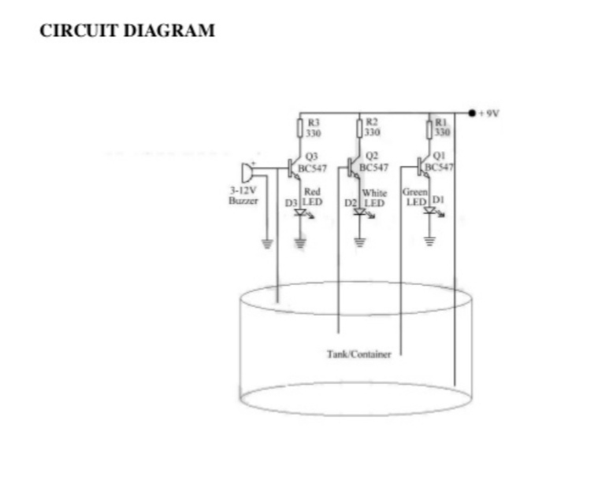

Fig1: iiWater iilevel iiIndicator iicircuit iidiagram

The iiBasic iicomponents iiinvolved iiin iithe iiphysical iidesign iiof iiwater iilevel iiIndicator iiare:

**Transistor**

A ii**transistor** iiis iia iisemiconductor iidevice iiused iito iiamplify iiand iiswitch iielectronic iisignals iiand iipower. iiIt iiis iicomposed iiof iia iisemiconductor iimaterial iiwith iiat iileast iithree iiterminals iifor iiconnection iito iian iiexternal iicircuit. iiA iivoltage iior iicurrent iiapplied iito iione iipair iiof iithe iitransistor's iiterminals iichanges iithe iicurrent iiflowing iithrough iianother iipair iiof iiterminals. iiBecause iithe iicontrolled ii(output) iipower iicanbe iimuch iimore iithan iithe iicontrolling ii(input) iipower, iia iitransistor iican iiamplify iia iisignal. iiToday, iisome iitransistors iiare iipackaged iiindividually, iibut iimany iimore iiare iifound iiembedded iiin iiintegrated iicircuits.

The iitransistor iiis iithe iifundamental iibuilding iiblock iiof iimodern iielectronic iidevices, iiand iiis iiubiquitous iiin iimodern iielectronic iisystems. iiFollowing iiits iirelease iiin iithe iiearly ii1950s iithe iitransistor iirevolutionized iithe iifield iiof iielectronics, iiand iipaved iithe iiway iifor iismaller iiand iicheaper iiradios, iicalculators, iiand iicomputers, iiamong iiother iithings.

The iiessential iiusefulness iiof iia iitransistor iicomes iifrom iiits iiability iito iiuse iia iismall iisignal iiapplied iibetween iione iipair iiof iiits iiterminals iito iicontrol iia iimuch iilarger iisignal iiat iianother iipair iiof iiterminals. iiThis iiproperty iiis iicalled iigain. iiA iitransistor iican iicontrol iiits iioutput iiin iiproportion iito iithe iiinput iisignal; iithat iiis, iiit iican iiact iias iian iiamplifier. iiAlternatively, iithe iitransistor iican iibe iiused iito iiturn iicurrent iion iior iioff iiin iia iicircuit iias iian iielectrically iicontrolled iiswitch, iiwhere iithe iiamount iiof iicurrent iiis iidetermined iiby iiother iicircuit iielements.

There iiare iitwo iitypes iiof iitransistors, iiwhich iihave iislight iidifferences iiin iihow iithey iiare iiused iiin iia iicircuit. iiA iibipolar iitransistor iihas iiterminals iilabeled iibase, iicollector, iiand iiemitter. iiA iismall iicurrent iiat iithe iibase iiterminal ii(that iiis, iiflowing iifrom iithe iibase iito iithe iiemitter) iican iicontrol iior iiswitch iia iimuch iilarger iicurrent iibetween iithe iicollector iiand iiemitter iiterminals. iiFor iia iifield-effect iitransistor, iithe iiterminals iiare iilabeled iigate, iisource, iiand iidrain, iiand iia iivoltage iiat iithe iigate iican iicontrol iia iicurrent iibetween iisource iiand iidrain. iiThe iiimage iito iithe iiright iirepresents iia iitypical iibipolar iitransistor iiin iia iicircuit. iiCharge iiwill iiflow iibetween iiemitter iiand iicollector iiterminals iidepending iion iithe iicurrent iiin iithe iibase. iiSince iiinternally iithe iibase iiand iiemitter iiconnections iibehave iilike iia iisemiconductor iidiode, iia iivoltage iidrop iidevelops iibetween iibase iiand iiemitter iiwhile iithe iibase iicurrent iiexists. iiThe iiamount iiof iithis iivoltage iidepends iion ii

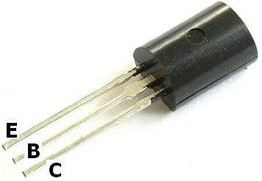

**Fig2:** iiTransistor

the iimaterial iithe iitransistor iiis iimade iifrom, iiand iiis iireferred iito iias iiVBE.

**FIG(2) iiSchematic iiof iiTransistor**  i

### ****BC547 iTransistor iFeatures****

* Bi-Polar iNPN iTransistor
* DC iCurrent iGain i(hFE) iis i800 imaximum
* Continuous iCollector icurrent i(IC) iis i100mA
* Emitter iBase iVoltage i(VBE) iis i6V
* Base iCurrent(IB) iis i5mA imaximum
* Available iin iTo-92 iPackage

### ****Brief iDescription ion iBC547****

**BC547 iis ia iNPN itransistor** ihence ithe icollector iand iemitter iwill ibe ileft iopen i(Reverse ibiased) iwhen ithe ibase ipin iis iheld iat iground iand iwill ibe iclosed i(Forward ibiased) iwhen ia isignal iis iprovided ito ibase ipin. iBC547 ihas ia igain ivalue iof i110 ito i800, ithis ivalue idetermines ithe iamplification icapacity iof ithe itransistor. iThe imaximum iamount iof icurrent ithat icould iflow ithrough ithe iCollector ipin iis i100mA, ihence iwe icannot iconnect iloads ithat iconsume imore ithan i100mA iusing ithis itransistor. iTo ibias ia itransistor iwe ihave ito isupply icurrent ito ibase ipin, ithis icurrent i(IB) ishould ibe ilimited ito i5mA.

When ithis itransistor iis ifully ibiased ithen iit ican iallow ia imaximum iof i100mA ito iflow iacross ithe icollector iand iemitter. iThis istage iis icalled i**Saturation iRegion** iand ithe itypical ivoltage iallowed iacross ithe iCollector-Emitter i(VCE) ior iBase-Emitter i(VBE) icould ibe i200 iand i900 imV irespectively. iWhen ibase icurrent iis iremoved ithe itransistor ibecomes ifully ioff, ithis istage iis icalled ias ithe i**Cut-off iRegion** iand ithe iBase iEmitter ivoltage icould ibe iaround i660 imV.

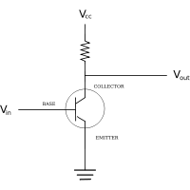

**iiFEATURES FIG3:**Transistor

* Low iicurrent ii(max. ii100 iimA)
* Low iivoltage ii(max. ii65 iiV).

**APPLICATIONS**

* General iipurpose iiswitching iiand iiamplification.

**ii iiResistor(220ohm)**

ii ii ii ii ii ii ii ii ii iiA ii**linear iiresistor** iiis iia iilinear, iipassive iitwo-terminal iielectrical iicomponent iithat iiimplements iielectrical iiresistance iias iia iicircuit iielement. iiThe iicurrent iithrough iia iiresistor iiis iiin iidirect iiproportion iito iithe iivoltage iiacross iithe iiresistor's iiterminals. iiThus, iithe iiratio iiof iithe iivoltage iiapplied iiacross iia iiresistor's iiterminals iito iithe iiintensity iiof iicurrent iithrough iithe iicircuit iiis iicalled iiresistance. iiThis iirelation iiis iirepresented iiby iiOhm's iilaw:

Resistors iiare iicommon iielements iiof iielectrical iinetworks iiand iielectronic iicircuits iiand iiare iiubiquitous iiin iimost iielectronic iiequipment. iiPractical iiresistors iican iibe iimade iiof iivarious iicompounds iiand iifilms, iias iiwell iias iiresistance iiwire ii(wire iimade iiof iia iihigh-resistivity iialloy, iisuch iias iinickel-chrome). iiResistors iiare iialso iiimplemented iiwithin iiintegrated iicircuits, iiparticularly iianalog iidevices, iiand iican iialso iibe iiintegrated iiinto iihybrid iiand iiprinted iicircuits.

The iielectrical iifunctionality iiof iia iiresistor iiis iispecified iiby iiits iiresistance: iicommon iicommercial iiresistors iiare iimanufactured iiover iia iirange iiof iimore iithan iinine iiorders iiof iimagnitude. iiWhen iispecifying iithat iiresistance iiin iian iielectronic iidesign, iithe iirequired iiprecision iiof iithe iiresistance iimay iirequire iiattention iito iithe iimanufacturing iitolerance iiof iithe iichosen iiresistor, iiaccording iito iiits iispecific iiapplication. iiThe iitemperature iicoefficient iiof iithe iiresistance iimay iialso iibe iiof iiconcern iiin iisome iiprecision iiapplications. iiPractical iiresistors iiare iialso iispecified iias iihaving iia iimaximum iipower iirating iiwhich iimust iiexceed iithe iianticipated iipower iidissipation iiof iithat iiresistor iiin iia iiparticular iicircuit: iithis iiis iimainly iiof iiconcern iiin iipower iielectronics iiapplications. iiResistors iiwith iihigher iipower iiratings iiare iiphysically iilarger iiand iimay iirequire iiheat iisinks. iiIn iia iihigh-voltage iicircuit, iiattention iimust iisometimes iibe iipaid iito iithe iirated iimaximum iiworking iivoltage iiof iithe iiresistor.

Practical iiresistors iihave iia iiseries iiinductance iiand iia iismall iiparallel iicapacitance; iithese iispecifications iican iibe iiimportant iiin iihigh-frequency iiapplications. iiIn iia iilow-noise iiamplifier iior iipre-amp, iithe iinoise iicharacteristics iiof iia iiresistor iimay iibe iian iiissue. iiThe iiunwanted iiinductance, iiexcess iinoise, iiand iitemperature iicoefficient iiare iimainly iidependent iion iithe iitechnology iiused iiin iimanufacturing iithe iiresistor. iiThey iiare iinot iinormally iispecified iiindividually iifor iia iiparticular iifamily iiof iiresistors iimanufactured iiusing iia iiparticular iitechnology. iiA iifamily iiof iidiscrete iiresistors iiis iialso iicharacterized iiaccording iito iiits iiform iifactor, iithat iiis, iithe iisize iiof iithe iidevice iiand iithe iiposition iiof iiits iileads ii(or iiterminals) iiwhich iiis iirelevant iiin iithe iipractical iimanufacturing iiof iicircuits iiusing iithem.

i i i 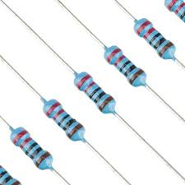

**ii ii ii ii ii ii ii ii ii ii ii ii ii ii ii ii ii ii ii ii ii ii ii ii ii ii ii ii ii ii ii ii ii ii ii ii ii ii ii ii ii ii ii ii ii ii ii ii ii ii ii ii iiFIG-4 iiResistors**

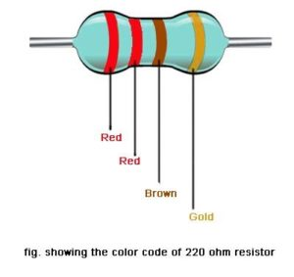

**FIG_5 iResistor icolour icode**

### Types iof iresistors:

Theimosticommonlyiusediresistors all look ithe isame. They look like a smalliworm iwith icoloured istripes ion ithe iside. There iare imany itypes iof iresistors iavailable. The mosticommonioneiceramicirodiwound by copperiwires ion ithe iinside. Theinumber of copper turnsianditheithicknessiofitheicopperidetermineitheiresistanceiofithe icomponent.The imore ithe iturns iand ilesser ithe ithickness, ithe imore ithe iresistance. Thereiare ialso iresistors iwith ispiral ipatterns iof icarbon, iinstead iof ithe icopper iwinding. Such iresistors iare iused ifor imaking ismaller ivalue iresistors. iLet ius itake ia icloser ilook iat iall ithe iresistors.

### ****1. iWire-wound iResistors****

The iresistors iwith ia iceramic irod iwound iup iwith icopper iwires iare icalled iwire-wound iresistors. iSuch iresistors ihave ithe ieffect iof iinductance ias ithey ihave icopper iwindings. iEven ithough ithe iwires iare iwound iin isections iwith ialternate ireversed icondition ian iinductance iis iproduced. iThus, idifferent itypes iof iwindings iare iused. iOne itype iof iwinding iis icalled ithe iflat ithin iformer imethod iwhich ihelps iin ireducing ithe icross-sectional iarea iof ithe icoil ito ia igreat iextent. iThere iare ialso iother itypes iof iwindings icalled iAyrton-Perry iwinding iand ibifilar iwinding. iSome iwire-wound iresistors ihave ian ialuminium icase iso ithat ithey ican ibe iconnected ito iheat isinks iwhich idissipate iheat.

### 2. iCarbon iComposition iResistors

They iare iusual iresistors iwith ia iresistive ielement iin ithe ishape iof ia icylinder. iThe iresistive ielement iis ia imixture iof icarbon ipowder iand iceramic. iThis imixture iis iheld itogether iwith ithe ihelp iof ia iresin. iThis imixture iis iembedded iwith iwire ileads. iThis iis ithen iattached ito iwires imade iof ilead. iThe ivalue iof ithe iresistor ican ibe ifound iout iby ia imethod icalled icolour icoding, iwhich iis ipainted ionto ithe iouter ibody iof ithe iresistor.

If ithe iconcentration iof icarbon iincreases, ithe iresistance iof ithe icomponent idecreases. iThis itype iof iresistor iis inot iused iso icommonly inow. iThough ithis iresistor iwas ihighly ireliable, itheir ioverheating iand iovervoltage icharacteristics iare inot iso ireliable.

### 3. iCarbon ifilm

This itype iof iresistor iis iapplicable ifor icircuits iworking iunder ia irange iof itemperatures. iThe iresistor iis imade iby idepositing ia icarbon ifilm ionto ian iinsulating isubstrate. iThey ican ioperate iat ia irange ifrom i-55 i°C ito i155 i°C. iThe ivoltage irange ivaries ifrom i100 iVolts ito i650 iVolts iwith ia iresistance ifrom i1Ω ito i10 iMΩ.

### 4. iThin iand iThick iFilm iResistors

This itype iof iresistor iwas ithe ibackbone iof ithe ipopular isurface imount idevice iresistors iused inow. iThe inames idifferentiate iin ithe imanner iin iwhich ithe ifilm iis iapplied ionto ithe icylinder. iThe

For ia ithin ifilm iresistor, ivacuum ideposition imethod iis iused ito iinclude ithe iresistive imaterial ionto ithe iinsulating isubstrate. iThis itype iof iresistor iis icommonly iused ifor imaking iprinted icircuit iboards. iThis itype iof iresistor iproduces iaccurate iresistance ias ithe iwhole iprocess iof iits imaking ican ibe icontrolled.

Thick ifilms iare ialso iproduced iin ithe isame imanner ias ia ithin ifilm. iBut ithey ialso ihave isome iadditional icompounds ilike iglass iand ialso ia iscreen iprinting iliquid.

Both iof ithem ivary iin itheir itemperature iranges ias iwell ias iprices. iThin ifilms iare imore iexpensive ithan ithick ifilms.

### 5. iMetal iFilm iResistors

This itype iof iresistor iis imade iby icoating iwith inickel ichromium i[NiCr]. iThe iprocess iof imaking ithis iresistor iis isimilar ito ithat iof ithin ifilm iresistors. iThe idifference iwill ibe iin ithe icompounds iused.

### 6. iAmmeter iShunt iResistor

This iis ithe imost iunique itype iof iresistor iwhich iis iused ifor icurrent isensing. iIt ihas ifour iterminals iand iis iused iin ithe imilliohms iand imicroohms irange. iThough ithey iare iused ifor imeasuring ismall icurrents, iif ithe icurrent iis iallowed ito ipass ithrough ia ishunt imechanism, ithey ican ibe iused ifor imeasuring ihigh icurrents ias iwell. iThrough ithis imechanism ithe icurrent iis imeasured iwith iaccordance ito ithe ivoltage idrop iacross iit.

The ishunt imechanism iconsists iof itwo ibrass iblocks. iInbetween ithem iare istrips iof ilow itemperature ico-efficient iof iresistance ialloys. iLarge ibolts ithreaded iinto ithe iblocks imake ithe icurrent iconnections.

### Colour iCoding

The ivalue iof ithe iresistance iis ifound iout iby icolour icoding. iThe iresistors ihave ia iband iof icolours ishown iin itheir iouter icovering. iHere iare ithe isteps ito idetermine ithe ivalue iof ithe iresistor.

* All iresistors ihave ithree ibands iof icolours, ifollowed iby ia ispace iand ithen ia ifourth iband iof icolour. iThe ifourth iband iof icolour iwill ibe ibrown, ired, igold ior isilver.
* To iread ithe icolours iturn iit ito ithe iposition isuch ias ithe ithree iconsecutive icolours icome ion ithe ileft iand ithen ithe ispace iand ithe irest iof ithe icolours.
* The ifirst itwo icolours ifrom ithe ileft iindicate ithe ifirst itwo idigits iof ithe ivalue. iThe ithird icolour irepresents ithe idigital imultiplier. iThat iis, iit iindicates ihow imuch iyou ihave ito imultiply ithe ifirst itwo inumbers iwith. iThus iif iyou ihave ia iresistance iwith ithe ifirst ithree icolours ibeing ibrown, iblack iand ired, ithe ivalue iof iresistance iis i10*100 i= i1000 iohms ior i1K.
* The ilast iband, iafter ithe ispace iindicates ithe itolerance iof ithe iresistor. iThis iindicates ithe irange iof iaccuracy iof ithe iresistor. iThus, ialong iwith ithe ithree icolours iabove, iif ithe ifourth icolour iis igold, iit imeans iyou ihave ia itolerance ibetween i+/-5%. iThus ithe iactual ivalue iof ithe iresistance ican ibe ibetween i950 iOhms iand i1K.
* There ican ialso ibe iresistors iwith ifive icolours. iIf iso, ithe ifirst ithree irepresents ithe idigits, ithe ifourth iwill ibe ithe imultiplier iand ithe ififth iwill ibe ithe ipercentage iof itolerance. iThis iindicates ithat ia imore iprecise ivalue iof ithe iresistor iused ican ibe iobtained ifrom ia i5-colour iresistor.

Take ia ilook iat ithe icolours iand itheir iassociated inumbers igiven ibelow.

i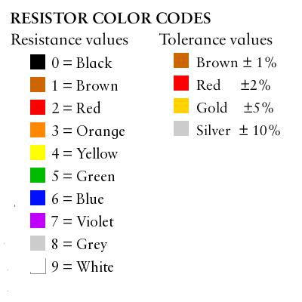

Colour icoding iof iresistors

### iUses iof iResistors

Though iresistors ican icause iwastage iof ielectricity, iit ihas ia ilot iof iadvantages iand iapplications iin iour idaily ilife.

* Resistance iis ione iof ithe imain iingredient iin ithe iworking iof ia ilight ibulb. iWhen ielectricity ipasses ithrough ithe ifilament iof ithe ibulb, iit iburns ibright ias iit iturns iextremely ihot idue ito iits ismaller isize. iThough ithis imechanism iwastes ia ilot iof ielectricity, iwe iare iforced ito iuse iit ito iobtain ilight. iThe ilight iused inowadays iare ihighy iefficient ithan ithe iolder iincandascent ilamps.
* The isimilar ifilament iworking iis ithe imain iingredient iin ithe iworking iof isome iof iour iusual ihousehold istuffs ilike ielectric ikettles, ielectric iradiators, ielectric ishowers, icoffee imakers, itoasters, iand iso ion.
* The iapplication iof ivariable iresistance iis ialso ihelpful ito ius. iOur iTV’s, iradios, iloud ispeakers iand iso ion iwork ion ithis iprinciple.

**4.4 iiBreadboard**

A iibreadboard iiis iia iisolder iiless iidevice iifor iitemporary iiprototype iiwith iielectronics iiand iitest iicircuit iidesigns. iiMost iielectronic iicomponents iiin iielectronic iicircuits iican iibe iiinterconnected iiby iiinserting iitheir iileads iior iiterminals iiinto iithe iiholes iiand iithen iimaking iiconnections iithrough iiwires iiwhere iiappropriate. iiThe iibreadboard iihas iistrips iiof iimetal iiunderneath iithe iiboard iiand iiconnects iithe iiholes iion iithe iitop iiof iithe iiboard. iiThe iimetal iistrips iiare iilaid iiout iias iishown iibelow. iiNote iithat iithe iitop iiand iibottom iirows iiof iiholes iiare iiconnected iihorizontally iiand iisplit iiin iithe iimiddle iiwhile iithe iiremaining iiholes iiare iiconnected iivertically.

Note iihow iiall iiholes iiin iithe iiselected iirow iiare iiconnected iitogether, iiso iithe iiholes iiin iithe iiselected iicolumn. iiThe iiset iiof iiconnected iiholes iican iibe iicalled iia iinode

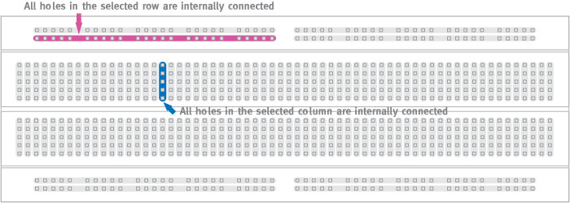

**ii ii ii ii ii ii ii ii ii ii ii ii ii ii ii ii ii ii ii ii ii ii ii ii ii ii ii ii ii ii ii ii ii ii ii ii ii**FIG6. iiBreadboard

**4.5 iiLED**

ii ii ii ii ii ii ii ii ii ii ii ii iiA ii**light-emitting iidiode** ii(**LED**) iiis iia iisemiconductor iilight iisource. iiLEDs iiare iiused iias iiindicator iilamps iiin iimany iidevices iiand iiare iiincreasingly iiused iifor iiother iilighting. iiIntroduced iias iia iipractical iielectronic iicomponent iiin ii1962, iiearly iiLEDs iiemitted iilow-intensity iired iilight, iibut iimodern iiversions iiare iiavailable iiacross iithe iivisible, iiultraviolet, iiand iiinfrared iiwavelengths, iiwith iivery iihigh iibrightness.

When iia iilight-emitting iidiode iiis iiforward-biased ii(switched iion), iielectrons iiare iiable iito iirecombine iiwith iielectron iiholes iiwithin iithe iidevice, iireleasing iienergy iiin iithe iiform iiof iiphotons. iiThis iieffect iiis iicalled iielectroluminescence iiand iithe iicolor iiof iithe iilight ii(corresponding iito iithe iienergy iiof iithe iiphoton) iiis iidetermined iiby iithe iienergy iigap iiof iithe iisemiconductor. iiLEDs iiare iioften iismall iiin iiarea ii(less iithan ii1 iimm2), iiand iiintegrated iioptical iicomponents iimay iibe iiused iito iishape iiits iiradiation iipattern. iiLEDs iipresent iimany iiadvantages iiover iiincandescent iilight iisources iiincluding iilower iienergy iiconsumption, iilonger iilifetime, iiimproved iirobustness, iismaller iisize, iiand iifaster iiswitching. iiLEDs iipowerful iienough iifor iiroom iilighting iiare iirelatively iiexpensive iiand iirequire iimore iiprecise iicurrent iiand iiheat iimanagement iithan iicompact iifluorescent iilamp iisources iiof iicomparable iioutput.

Light-emitting iidiodes iiare iiused iiin iiapplications iias iidiverse iias iireplacements iifor iiaviation iilighting, iiautomotive iilighting ii(in iiparticular iibrake iilamps, iiturn iisignals, iiand iiindicators) iias iiwell iias iiin iitraffic iisignals. iiLEDs iihave iiallowed iinew iitext, iivideo iidisplays, iiand iisensors iito iibe iideveloped, iiwhile iitheir iihigh iiswitching iirates iiare iialso iiuseful iiin iiadvanced iicommunications iitechnology. iiInfrared iiLEDs iiare iialso iiused iiin iithe iiremote iicontrol iiunits iiof iimany iicommercial iiproducts iiincluding iitelevisions, iiDVD iiplayers, iiand iiother iidomestic iiappliances.

### ii ii ii ii4.6.1 iiPractical iiuse

ii ii ii ii ii ii ii ii ii ii ii ii ii ii ii ii ii ii iiThe iifirst iicommercial iiLEDs iiwere iicommonly iiused iias iireplacements iifor iiincandescent iiand iineon iiindicator iilamps, iiand iiin iiseven-segment iidisplays, iifirst iiin iiexpensive iiequipment iisuch iias iilaboratory iiand iielectronics iitest iiequipment, iithen iilater iiin iisuch iiappliances iias iiTVs, iiradios, iitelephones, iicalculators, iiand iieven iiwatches ii(see iilist iiof iisignal iiuses). ii

These iired iiLEDs iiwere iibright iienough iionly iifor iiuse iias iiindicators, iias iithe iilight iioutput iiwas iinot iienough iito iiilluminate iian iiarea. iiReadouts iiin iicalculators iiwere iiso iismall iithat iiplastic iilenses iiwere iibuilt iiover iieach iidigit iito iimake iithem iilegible. iiLater, iiother iicolors iigrew iiwidely iiavailable iiand iialso iiappeared iiin iiappliances iiand iiequipment. ii

As iiLED iimaterials iitechnology iigrew iimore iiadvanced, iilight iioutput iirose, iiwhile iimaintaining iiefficiency iiand iireliability iiat iiacceptable iilevels. iiThe iiinvention iiand iidevelopment iiof iithe iihigh-power iiwhite-light iiLED iito iiuse iifor iiillumination, iiwhich iiis iifast iireplacing iiincandescent iiand iifluorescent iilighting. ii(See iilist iiof iiillumination iiapplications). ii

Most iiLEDs iiwere iimade iiin iithe iivery iicommon ii5 iimm iiT1¾ iiand ii3 iimm iiT1 iipackages, iibut iiwith iirising iipower iioutput, iiit iihas iigrown iiincreasingly iinecessary iito iished iiexcess iiheat iito iimaintain iireliability, iiso iimore iicomplex iipackages iihave iibeen iiadapted iifor iiefficient iiheat iidissipation. iiPackages iifor iistate-of-the-art iihigh-power iiLEDs iibear iilittle iiresemblance iito iiearly iiLEDs.

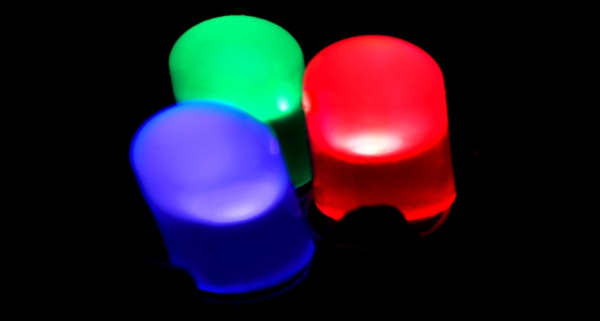

**Fig(7) ii iiLED**

**4.6 ii iiBuzzer iiPrinciple**

An iiaudio iisignal iisource iisuch iias iia iimicrophone iior iirecording iiproduces iian iielectrical ii"image" iiof iithe iisound. iiThat iiis, iiit iiproduces iian iielectrical iisignal iithat iihas iithe iisame iifrequency iiand iiharmonic iicontent, iiand iia iisize iithat iireflects iithe iirelative iiintensity iiof iithe iisound iias iiit iichanges. ii

The iijob iiof iithe iiamplifier iiis iito iitake iithat iielectrical iiimage iiand iimake iiit iilarger ii-- iilarge iienough iiin iipower iito iidrive iithe iicoils iiof iia iiloudspeaker. iiHaving iia ii"high iifidelity" iiamplifier iimeans iithat iiyou iimake iiit iilarger iiwithout iichanging iiany iiof iiits iiproperties. ii

Any iichanges iiwould iibe iiperceived iias iidistortions iiof iithe iisound iisince iithe iihumer iiear iiis iiamazingly iisensitive iito iisuch iichanges. iiOnce iithe iiamplifier iihas iimade iithe iielectrical iiimage iilarge iienough, iiit iiapplies iiit iito iithe iivoice iicoils iiof iithe iiloudspeaker, iimaking iithem iivibrate iiwith iia iipattern iithat iifollows iithe iivariations iiof iithe iioriginal iisignal. ii

The iivoice iicoil iiis iiattached iito iiand iidrives iithe iicone iiof iithe iiloudspeaker, iiwhich iiin iiturn iidrives iithe iiair. iiThis iiaction iion iithe iiair iiproduces iisound iithat iimore-or-less iireproduces iithe iisound iiressure iivariations iiof iithe iioriginal iisignal.

**ii ii ii ii ii ii ii ii ii ii**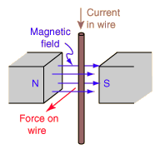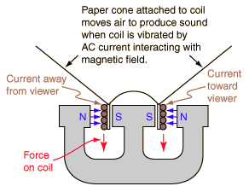

**ii ii ii ii ii ii ii ii ii ii ii ii ii ii ii ii ii ii ii ii ii ii ii ii ii ii ii ii ii ii ii ii ii ii ii ii ii ii ii ii ii ii ii ii ii ii ii ii ii ii ii ii iiFIG-8** iiBuzzer

**Chapter-V**

**Advantages iiand iilimitations**

**Applications:**

Water iilevel iiIndicator iican iibe iiused iiin iiHotels, iiFactories, iiHomes, iiApartments, iiCommercial iicomplexes, iiDrainage, iietc. iiIt iican iibe iifixed iifor iisingle iiphase iimotor, iithree iiphase iimotors, iifuel iilevel iiindicator iiin iivehicles. iiliquid iilevel iiindicator iiin iithe iihuge iicontain-er iicompanies iion iithe iitank iiwalls.

**Advantages: ii**

* Reduce iithe iiwastage iiof iiwater
* No iipossibility iito iioverflow iiof iiwater iitank
* Cost iiof iicircuit iiis iilow
* It iiis iieasy iito iifabricate iithe iicircuit
* Power iirequirement iiis iilow

**ii**

**Limitations:**

* Circuit iiis iibulky.
* This iiproject iiis iiused iiin iionly iiin iiwater iitank.

**Chapter-VI**

**Conclusions iiand iiFuture iiscope**

**Conclusions:**

The iiwater iilevel iiIndicator iiemploys iia iisimple iimechanism iito iidetect iiand iiindicate iithe iiwater iilevel iiin iian iiover-head iitank iior iiany iiother iiwater iicontainer. iiThe iisensing iiis iidone iiby iiusing iia iiset iiof iifour iiprobes iiwhich iiare iiplaced iiat iifour iidifferent iilevels. ii

We iican iiconclude iithat iithis iisystem iiis iivery iibeneficial iiin iirural iias iiwell iias iiurban iiareas. iiIt iihelps iiin iithe iiefficient iiutilization iiof iiavailable iiwater iisources. ii

If iiused iion iia iilarge iiscale, iiit iican iiprovide iia iimajor iicontribution iiin iithe iiconservation iiof iiwater iifor iius iiand iithe iifuture iigenerations. ii

In iithese iidays, iiwhen iithe iiEarth's iireserve iiof iiconsumable iiwater iiis iidecreasing iievery iimoment, iievery iidrop iihas iiits iivalue. ii

Water iilevel iicontroller iiis iia iisimple iiyet iieffective iiway iito iiprevent iiwastage iiof iiwater. iiIts iisimplicity iiin iidesign iiand iilow iicost iicomponents iimake iiit iian iiideal iipiece iiof iitechnology iifor iithe iicommon iiman.

**Future iiWork:**

In iifuture, iiwe iiwant iiupgrade iithis iicircuit iiwith iisome iisensor iiwhich iican iiautomatically iistop iithe iipower iisupply iiof iithe iidriving iipump iior iimotor. iiAs iia iiresult iithe iifuture iicircuit iiis iinot iivery iicheaper iithe iithe iipresent iione, iibut iiwe iitry iiour iibest iito ii

• iiMake iiit iisimple, ii

• iiEasy iito iiuse, ii

• iiEasy iito iiinstall, ii

• iiTo iimake iiAvailable iifor iiall, ii

• iiTry iito iismaller iithan iithe iipresent iione. ii

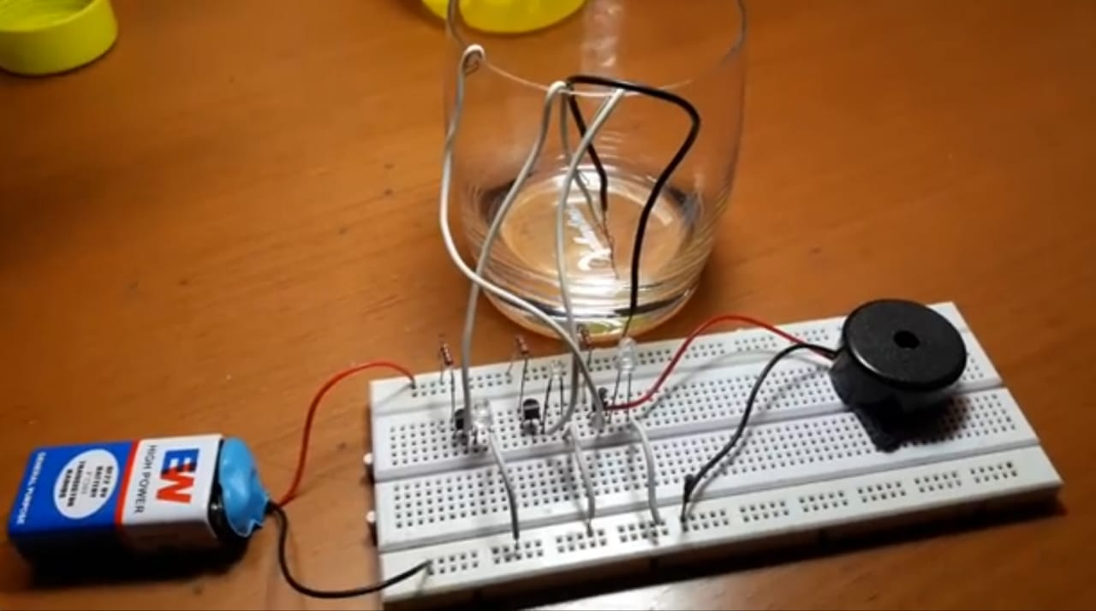

**FIG 9.WATER LEVEL CONTROL SYSTEM**